**Microsoft Azure Free Trial Account – Steps**

If you have Microsoft Account please follow below steps otherwise skip Account creation steps.

**Pre-requisites: Microsoft Account (Outlook or Hotmail or Live)**

Click on **Create free account** button.

Enter Personal details

**Step 1:** Open Microsoft Azure Free trial link:

<https://azure.microsoft.com/en-us/free/>

Click on Start free option

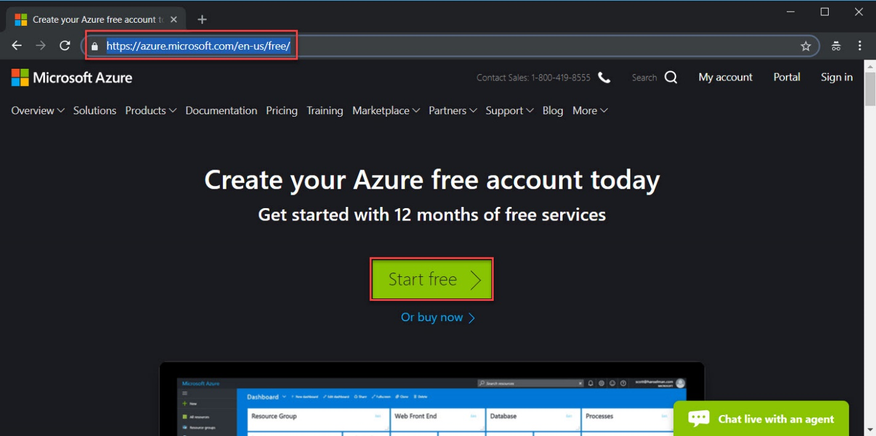

**Step 2:** Enter **Microsoft Email Id**

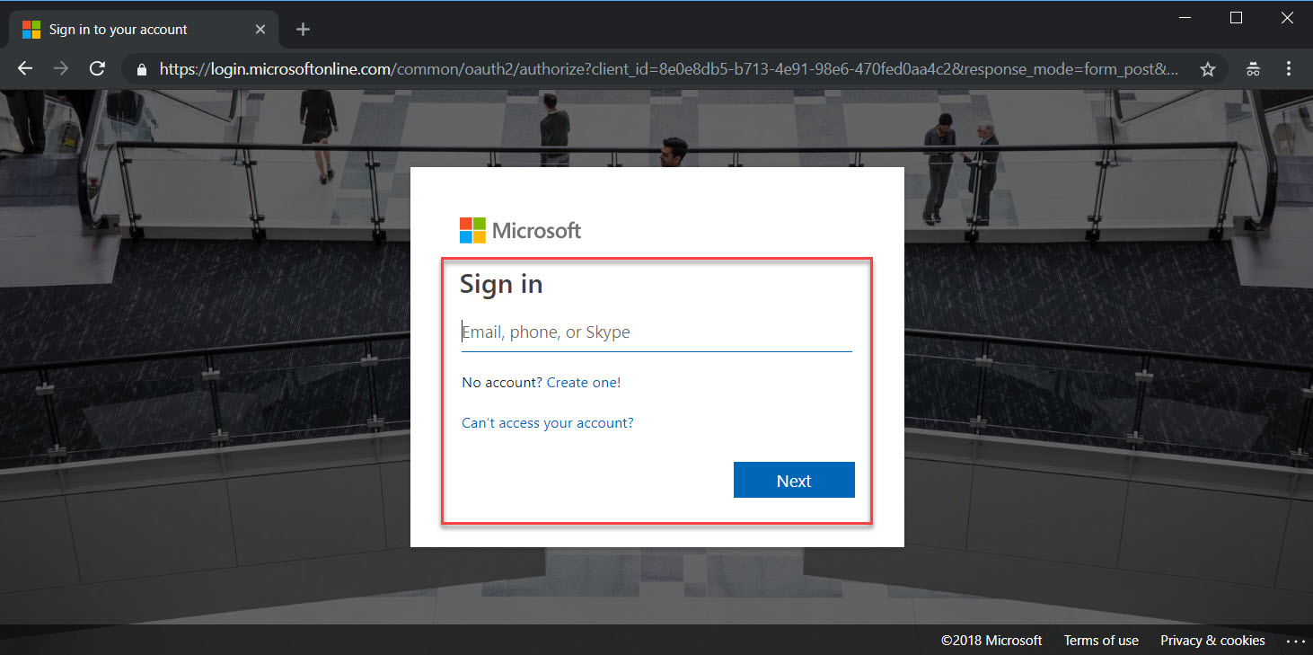

**Step 3:** Enter **Personal Information**

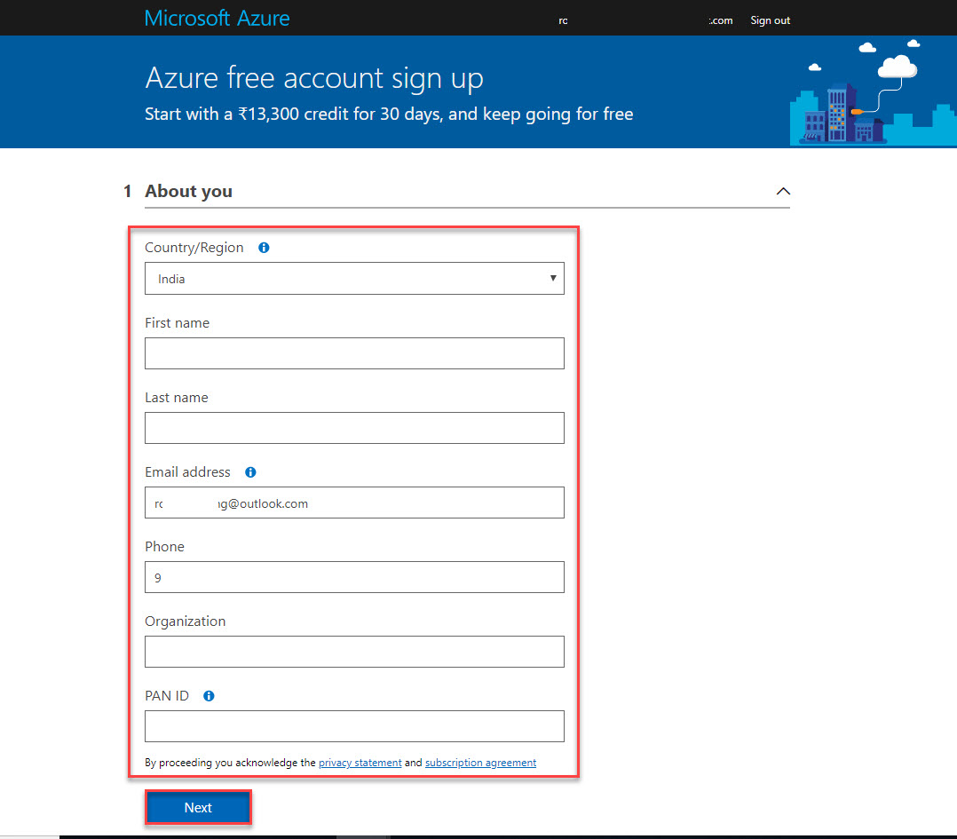

**Step 4:** Enter **Mobile Number verify** with Text me or Call me option

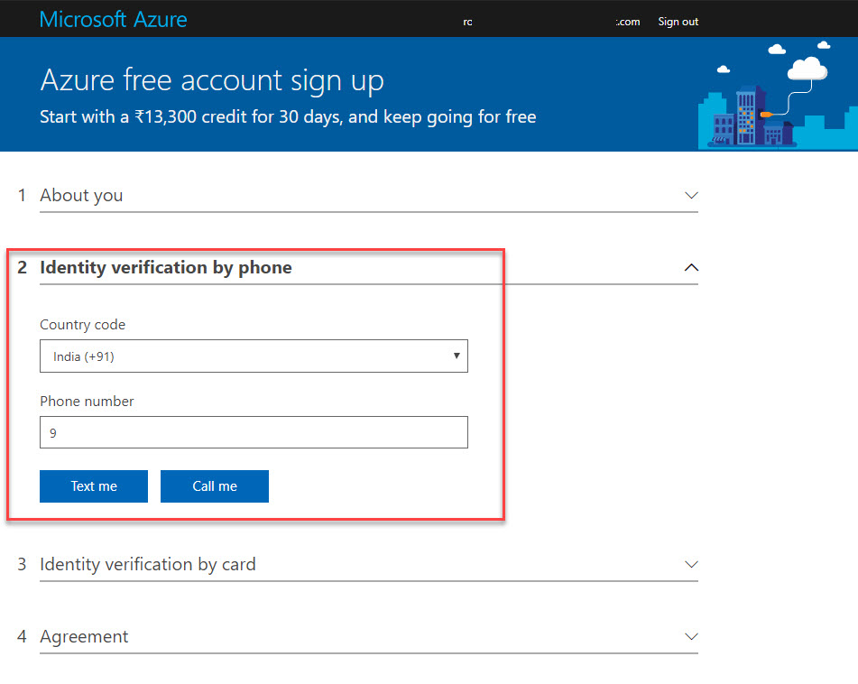

**Step 5:** Enter Credit Card Details.

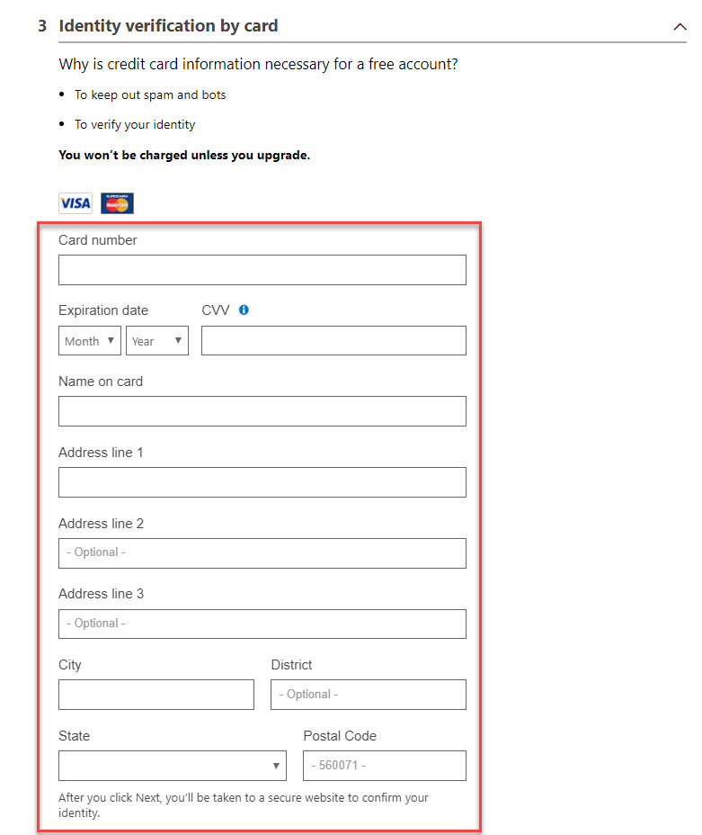

Accept the Agreement.

**Step 6:** After verify with all details Azure Portal will open as below:

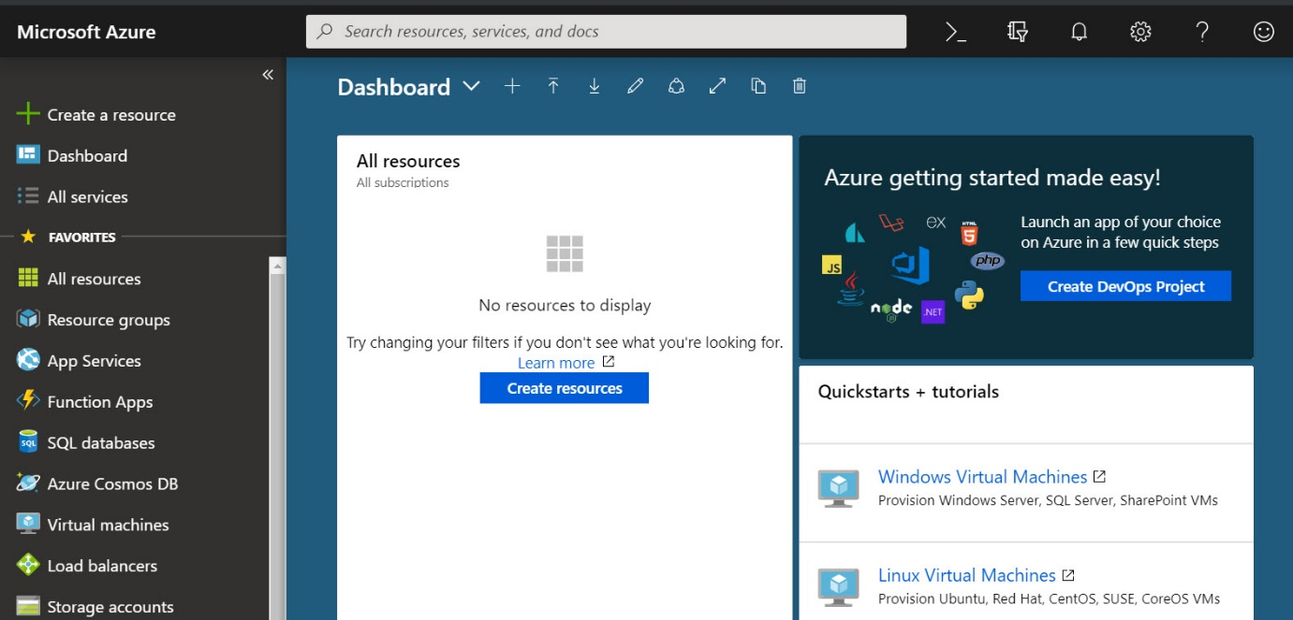

**Step 7:** To verify Free Trial account activated or not follow bellow steps

Click on **All Services -> Subscription**

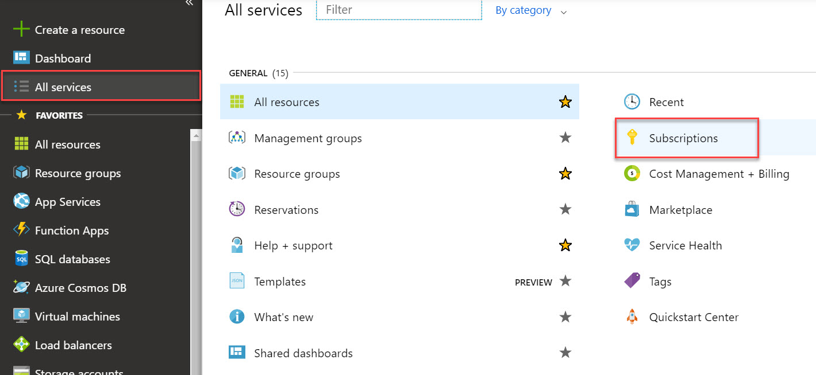

Free Trial Subscription will list as below.

